AGENTS AND DISTRIBUTORS - RECRUITMENT MAP

Agents and distributors recruitment is a very simple mechanism. The exact number of agents available in the next period depends on:

1. Number of agents employed in the previous period;
2. Commission;
3. Reward;
4. Euro exchange rate (only for distributors).

Using information about available agents in the next period from several reports, you can build a map. Map will graphically show you zones and distribution of available agents based on the above factors.

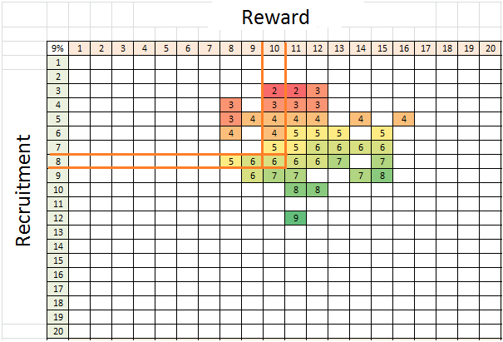

You can see a part of such map with colored zones of available agents where commission is 9%. Horizontal - reward dependence. Vertical - recruitment dependence (number of employed agents).

Example, we need to know how many agents to recruit if we need 6 agents in the next period with commission 9% and reward 10. Horizontal line - reward 10, descends vertically to the intersection with the cell, where it will be 6 and look for the intersection with the vertical line - recruitment 8. That is it, if commission 9%, reward 10, recruitment 8, we will every time get 6 agents.

Step by step, map is built for the commission 8%, 7%, 6%, etc. On the map you will see boundaries of the recruitment zones and number of agents. This way you can compare the various options for hiring required number of agents and find optimal values in order to save costs (minimums).

For distributors, there is an additional factor - euro exchange rate. The higher it is, the better the conditions for recruitment and the more distributors will be hired. Turning point (boundry) for this factor is euro exchange rate >= 1.25, rate > 0.67 and < 1.25, rate < 0.67. For each of the cases you need to build a separate map, because zones shift +/- 1 distributor.

*Hint - agents minimums (reward and recruitment) are the same for commission ranges 3-5%, 6-8%, 9-11%. That is why more profitable to play at the lower boundary of range with commission 3%, 6% and 9%. If commission is less than the lower boundary range by 1% (5%, 8%, 11%), you will need to increase reward or recruit more agents to get the same number of available agents in the next period, so it will be more expensive.*

代理商和经销商 - 招聘地图

代理和分销商招聘是一个非常简单的机制。下一期可用代理的确切数量取决于：

1．上一期的代理商招聘数量；

2．佣金：

3．支持费用；

4．汇率（仅限经销商）。

在下一个时期使用有关可用代理的信息，您可以创建一个地图。 地图将根据上述因素以图形方式显示可用代理的区域和分布。



你可以看到这样一个地图的一部分，有彩色区域的可用代理，佣金是9％。 水平 - 奖励依赖。 垂直 - 招聘依赖（就业代理人数）。

例如，如果我们在下一期需要6名代理商，佣金为9％，并获得奖励10，则需要知道有多少代理商。水平线 - 奖励10，垂直下降到与单元格交集的位置，并将其显示为6 对于垂直线的交叉点 - 招聘8.就是这样，如果佣金9％，奖励10，招聘8，我们每次都会得到6个代理。

一步一步地，地图是建立在委员会8％，7％，6％等。在地图上，您将看到招聘区域和代理人的数量。 这样，您可以比较招聘所需代理人数的各种选项，并找到最佳值，以节省成本（最小值）。

对于分销商，还有一个额外的因素 - 欧元汇率。 越高，招聘条件越好，招聘人员越多。 这个因素的转折点（边界）是欧元汇率> = 1.25，利率> 0.67和<1.25，利率<0.67。 对于每种情况，您需要构建单独的地图，因为区域向+/- 1分销商移动。

提示 - 佣金最少（奖励和招聘）的佣金范围为3-5％，6-8％，9-11％。 这就是为什么要在3％，6％和9％的下限范围内发挥更大的利润。 如果佣金小于下限1％（5％，8％，11％），您需要增加奖励或招募更多的代理商以获得相同数量的可用代理商在下一个时期，所以会更贵。